EXPERIMENT-1
ROLL NO:240701313 NAME: MITHULESH J

USER INTERFACE AND DESIGN
COMAPARSION OF UI DESIGN BETWEEN TWO FIGMA CREATION
BAD WEBSITE:

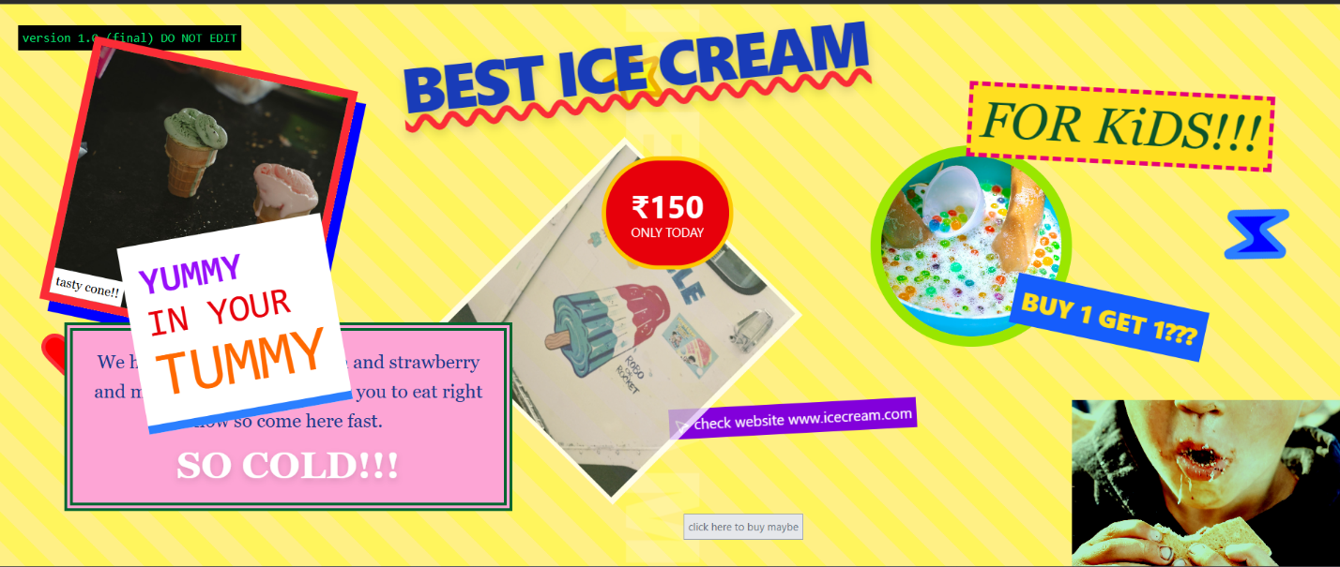
GOOD WEBSITE:

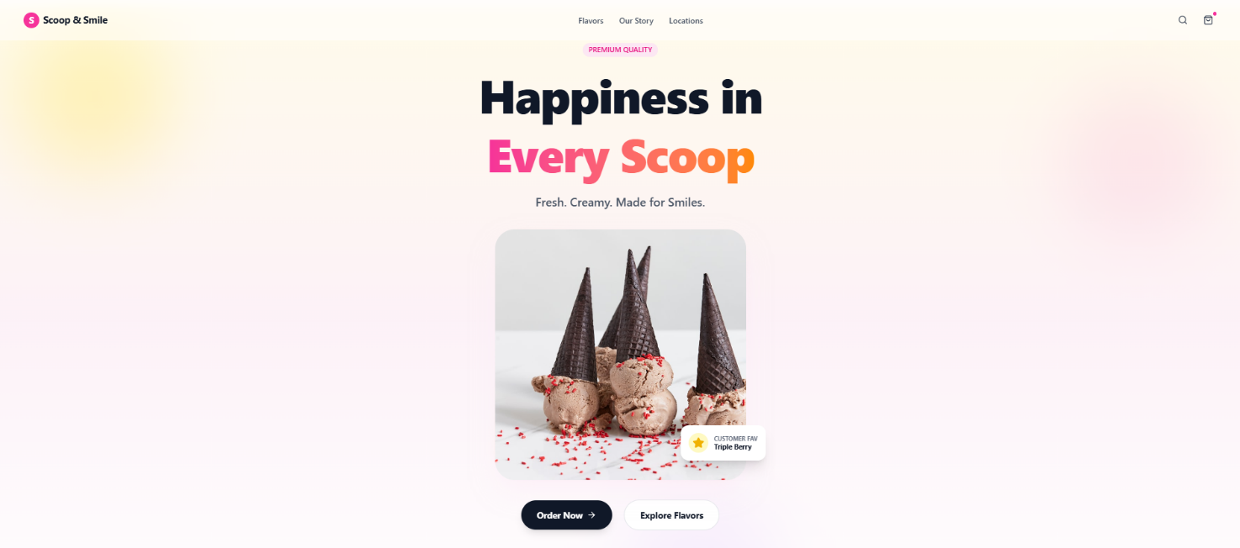

PROTOTYPE LINK:
https://www.figma.com/make/MpA4Gle8pbCgHUHp9zgxHN/Premium-Ice-Cream-Hero-Banner?t=bwH48gJbzTlsnQEK-1

The two websites have distinct designs and approaches. Here's a comparison:

BAD WEBSITE (IcePop)

1. Design Style:

Minimalistic and plain layout.

Focused on showcasing ice cream cones with large, colorful images.

Uses bright and contrasting background colors (yellow, pink, green) for different ice cream flavors.

Lacks visual consistency across sections.

2. Content:

Displays three ice cream flavors with their names and a simple “View More” button.

Content is very short and purely informational.

No description of taste, quality, or uniqueness.

3. Navigation:

A very basic navigation bar with only essential icons (cart and user profile).

No clear menu labels or guidance for users.

4. Purpose:

Mainly designed for quick product viewing.

Focuses only on displaying items, not on engaging users or building brand identity.

GOOD WEBSITE (CoolCream)

1. Design Style:

More creative and visually appealing layout.

Each section highlights a specific ice cream flavor (Strawberry, Vanilla, Chocolate) with matching colors and visuals.

Soft gradients, rounded shapes, and playful patterns create a fun and friendly atmosphere.

Consistent color palette and design theme throughout the website.

2. Content:

Includes short descriptive text explaining the flavor, freshness, and joy of each ice cream.

Highlights special offers such as “Flat 20% Off – Summer Special”.

Uses attractive slogans to emotionally connect with users.

3. Navigation:

A clear and well-structured navigation bar with options like Home, Flavors, Offers, About Us, and Contact.

Easy for users to explore different sections without confusion.

4. Purpose:

Designed to build strong brand identity.

Aims to create an enjoyable browsing experience while promoting offers and encouraging purchases.

Suitable for ice cream parlors or premium dessert brands.

Key Differences:

Focus:
The bad website is product-centric, while the good website emphasizes branding and user experience.

Design Aesthetics:
The bad design is simple but dull; the good design is colorful, themed, and engaging.

Content Depth:
The good website provides descriptions and promotions, whereas the bad website only lists products.

Target Audience:
The bad website targets quick browsing, while the good website targets families, kids, and brand-conscious customers.

